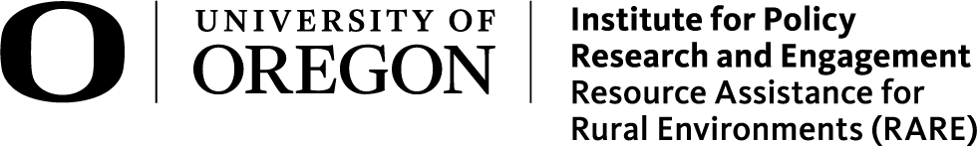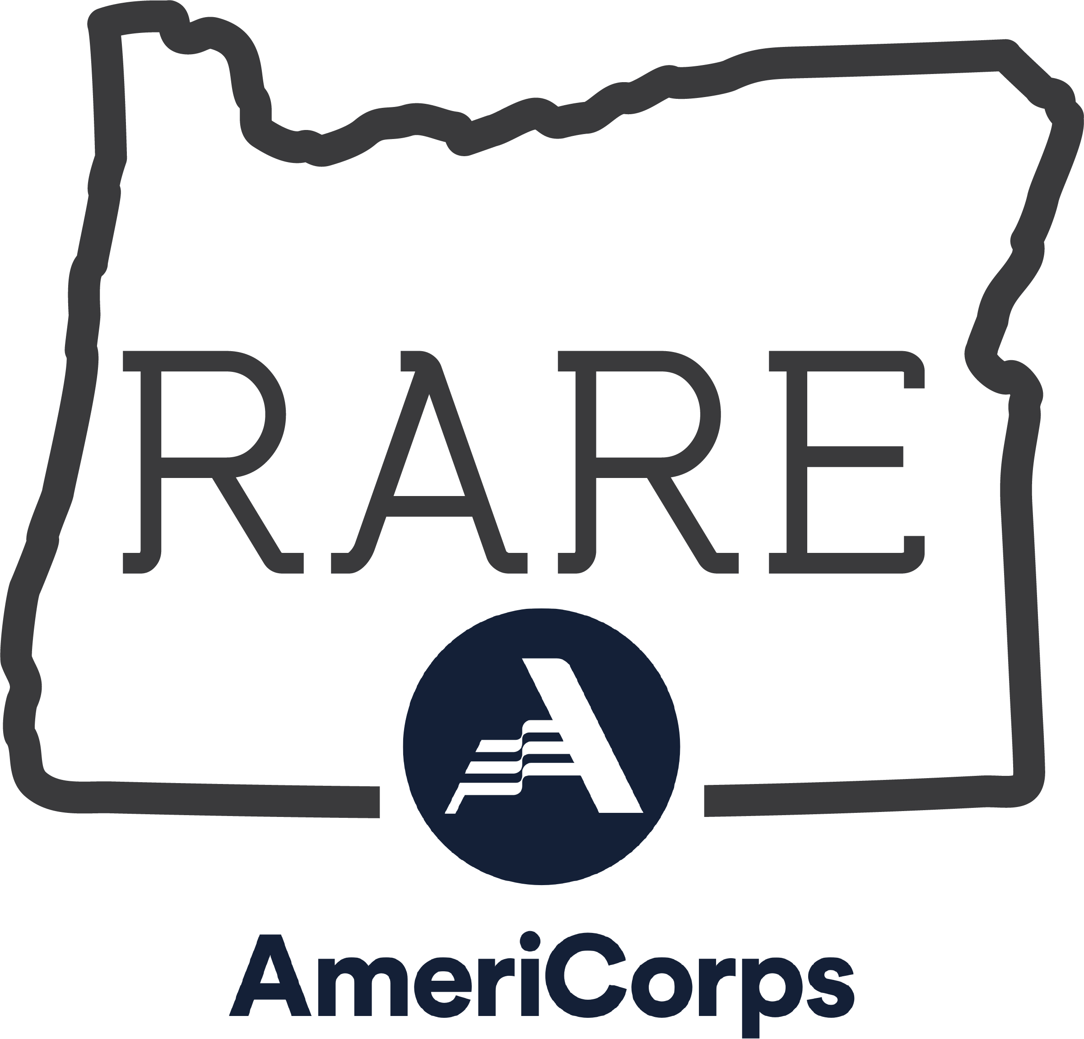

Resource Assistance for Rural Environments
RARE AmeriCorps Program
2021-2022 Member Application Preview

Instructions
Please use the following RARE AmeriCorps 2021-2022 Member Application Preview to develop responses for inputting into the Qualtrics application.
Remember that you won't be able to save the answers on the Qualtrics application and return at a later date - please don't fill out the application until you have all your materials prepared and ready to submit!
Completed applications must be submitted by 5pm on Friday, April 23, 2021. Don't forget to upload your essay questions and professional resume to the Qualtrics application! Your application will not be considered complete until we have received all your materials.
If you encounter issues or need assistance, please send us an email at rare@uoregon.edu or call 541-632-3147.
Program Disclaimers
This program is available to all without regard to race, color, national origin, disability, age, sex, political affiliation or in most instances, religion. You must be a United States citizen, United States national or lawful permanent resident to be eligible to serve in this program.
Qualified individuals with disabilities and those from diverse backgrounds are strongly encouraged to apply. We provide reasonable accommodation for qualified individuals and conduct all activities in fully accessible settings.
RARE is an AmeriCorps Program and upon successful completion of the program, eligible members may receive a Segal AmeriCorps Education Award.
Alternative formats of this application are available by contacting the program at rare@uoregon.edu or call 541-632-3147.
Begin!
When you have all your materials compiled, please access the application at: https://oregon.qualtrics.com/jfe/form/SV_0dfb8JukP8LuHqZ
RARE 2021-2022 MEMBER APPLICATION PREVIEW
Applicant’s Full Name
 | First |  | MI | Last
Current Address
 | Street (including Apt #, PO Box)
 | City |  |  |  |  | State |  | Zip
Phone |  |  | Cell
Email
Permanent Address
 | Street (including Apt #, PO Box) Note: this is an address where you can be contacted after you complete your service
 | City | State |  |  | Zip
If your partner or spouse is also applying to RARE, provide their name: Note: this information does not guarantee both partners will be accepted, nor that both partners will receive placements within the same region, but may influence the community placements that we share with you both. Community interviews will still be competitive. If you would not like this to be a consideration, leave this section blank.

How did you hear about the RARE Program?
Please indicate how you heard about the program by marking one or more boxes below
RARE Website | APA Website | RARE Member:
AmeriCorps Portal | Colleague/Supervisor | Social Media:
RPCV Career Link | Academic Department/Professor | Other Venue :

Previous Applications to AmeriCorps*VISTA or AmeriCorps
Have you previously applied to an AmeriCorps*VISTA or AmeriCorps program? |  |  |  | Yes No
If yes, indicate the month & year
Have you previously served as an AmeriCorps*VISTA or AmeriCorps member? |  |  | Yes No
If yes, indicate the month & year, name & location of project(s)
Did you complete your term(s) of service? | Yes No

Returned Peace Corps Volunteers
Are you a Returned Peace Corps Volunteer? | Yes No
If yes, indicate date(s) [month & year] and location(s)

Citizenship
Are you a United States citizen, United States national or lawful permanent resident? | Yes No

Service Preference

Mark the types of service you would prefer. Be as specific as possible as this information will be used to guide our interview process.
Community & Economic Development
Main St. & Downtown Development | Small City, County & Regional Planning | Small Business & Entrepreneurship Support
Nonprofit Development & Management | Rural Tourism & Destination Development | Rural Economic Resilience
Food Systems
Sustainable Food Systems | Food Access & Security
Environment & Sustainability
Renewable Energy | Natural Hazard Planning | Natural Hazard Mitigation
Climate Change & Community Resilience

Geographic Preference

While we cannot ensure an appropriate position will be available in a particular area, if you do have preferences for particular regions of Oregon, check all the regions you are interested in. Placement location depends on how your experience meets the needs of the community.
Central Oregon | Coast | Columbia River Gorge | I have no preference
Eastern Oregon | Southwestern Oregon | Willamette Valley
Are there any specific time and/or geographic constraints that may affect your placement? |  |  |  | Yes No
If yes, please explain

References

Please provide the name, phone number, and relationship to you of three professional references. At least one reference must be a current or former job supervisor. If you are a recent graduate, a professor, advisor or counselor may be substituted. Please do not list personal references.
 | Name | Organization | Email Address |  | Phone |  | Relationship
 | 1.
 | 2.
 | 3.

Educational Background
 | Name of School | State | City
Undergraduate
 | Major | Year Graduated | College/University
Graduate
 | Major | Year Graduated | College/University

Military Service
Have you ever served in the armed forces? |  | Yes No
If yes, please provide the following information
Branch of Services
Type of Discharge |  |  |  |  | Date of Discharge
Are you now a member of the ROTC, National Guard or Reserves? |  |  |  | Yes No
If yes, how will you fulfill your obligations to the RARE Program?

Legal Information

Answer the following questions in full. Existence of criminal conviction/adjudication may or may not, depending on the circumstance, disqualify you from consideration. However, any intentional misrepresentation or omission will disqualify you. Do not include minor traffic violations or offenses tried before a juvenile court.
Please note: your service in AmeriCorps cannot be used to satisfy parole or probation requirements.

Has a civilian or military court ever convicted you of any offenses, are you currently under charges for any offense, or are any civil suits or judgments pending against you? |  |  |  |  |  |  |  | Yes No
If yes, complete the remainder of the Legal Information Section. If no, skip to the next question.
Date |  | Charge
City, State |  | Action Taken
Are you currently on probation or parole? |  |  | Yes No
Provide the information below of the judge or probation officer whom we can contact to verify the above information.
Name |  |  |  |  |  | Phone
Address

Please note: We will conduct a search of the national sexual offender registry before accepting any applicant. Criminal Background Checks and FBI fingerprinting will be conducted before any placement is finalized. A RARE AmeriCorps applicant may submit a written request for access to review records that pertain to their application and were created relative to the AmeriCorps grant. A written appeal of the background check findings can be made to the Program Director. All program files are confidential.

Coursework & Skills
Please check the appropriate boxes below to indicate courses, special training, work experience and field-based learning. If you do not have experience in an area, just leave it blank.
 | EXPERIENCE
 | Class/Course  Training? |  | Work/Intern  Field-based?
Community/Economic Development
Land Use Planning
Meeting Facilitation/Group Processes
Natural Resources Planning
Planning/Statistical Analysis
Website Development/Management
Organizational Development
Project Management
Community Outreach/Engagement
Graphic Design
Public Speaking
Written Communication
Grant Writing
Large Document Creation
Geographic Information Systems (GIS)

Second Language Skills
Do you know any second languages? If so, which language?

Please check the associated box to indicate verbal and written proficiency.

 | Beginner | Conversational | Fluent | Native
Verbal
Written

Essay Questions
Please answer the following five questions, save as a PDF and upload below. Note the word limits for each question and answer accordingly.

- Please tell us how participation in the RARE program will help you reach your short and long term personal and professional goals. (word limit: 500)
- Please tell us how your background and values will contribute to the community that you will serve and to the RARE program as a whole. (word limit: 500)
- Please describe your perspectives on living/working in a rural community. (word limit: 250)
- Please briefly state what you view as your most significant accomplishment. (word limit: 250)
- Please complete the following statement: "People may be surprised when they learn that I..." (word limit: 250)

Resume

Please upload your professional resume as a PDF attachment.

Certification and Release
I certify that all of the statements made in this application are true, correct, and complete, to the best of my knowledge and are made in good faith. I understand that misinformation or omission of information could result in disqualification and/or termination as an AmeriCorps member.
Privacy Act Notice: The Privacy Act of 1974 (5 U.S.C § 552a) requires that the following notice be provided to you: The authority for collecting information from you in this application is contained in 42 U.S.C 12592 and 12615 of the National and Community Service Act of 1990 as amended, and 42 U.S.C 4953 of the Domestic Volunteer Service Act of 1973 as amended. You are advised that submission of the information is entirely voluntary, but the requested information is required in order for you to participate in AmeriCorps programs.
The principal purpose for requesting this personal information is to process your application for acceptance into an AmeriCorps program, and for other general routine purposes associated with your participation in an AmeriCorps program. These routine purposes may include disclosure of the information to federal, state, or local agencies pursuant to lawfully authorized requests, to present and former employers, references provided by you in your application, and educational institutions, for the purpose of verifying the information provided by you in your application. In some programs, the information may also be provided to federal, state, and local law enforcement agencies to determine the existence of any prior criminal convictions. The information will not otherwise be disclosed to entities outside of AmeriCorps and the Corporation for National Service without your prior written permission.
All position offers will be contingent upon:
- Status as a US citizen or national
- Search of the national sexual offender registry
- Criminal background check
- Continued program funding
By submitting your application packet electronically your typed signature certifies that the statements made on this 2019-2020 AmeriCorps Member Application are true and accurate.
Name of Applicant
Date

Optional Demographic Question
Thank you for completing your application! Before you submit, we are hoping to gather some demographic information. This information will not be considered as part of your application. Any information you chose to provide is confidential and will be redacted from your application during the review process.

Why are we collecting this information?

As a career pipeline program, the RARE AmeriCorps Program aims to increase representation of communities who are under-represented in the public service leadership, including but not limited to Black, Indigenous, and people of color, women and transgendered people, members of the LGBTGIA+ community, people with disabilities, and first generation college graduates. An important step in supporting representation is tracking who applies and is accepted to our program. This will help us improve our recruitment and placement process for future applicants. This information is for tracking purposes only and will not be considered as part of your application.

Which best describes your race or ethnic background? Select all that apply
American Indian/Alaska Native | Asian/Pacific Islander | Black/African American
Hispanic/Latino/a/x | White/Caucasian | Other:

Do you identify as a person with a disability?
Yes | No

Which best describes your gender identity? (continued on next page)
Agender | Genderqueer | Man
Non-binary | Woman | Trans Woman
Trans Man | Transgender | Questioning or unsure
Identity or identities not listed (please specify):

Do you identify as a member of the LGBTQIA+ community?
Yes | No

Has one or more of your parents or primary guardians completed a degree from a four-year college?
Yes | No

ALMOST DONE!

Please review your application before submitting to Qualtrics. Once you have submitted, you won't be able to make changes.
When you have reviewed your application and are satisfied, proceed to the Qualtrics application: https://oregon.qualtrics.com/jfe/form/SV_0dfb8JukP8LuHqZ

